Processional
Quinceanera Grandparents:
Quinceanera Parents:
Quinceanera Padrinos:
Quinceanera Siblings:

Specify if Damas and Chammelans are walking together or separately. See Layout for placement
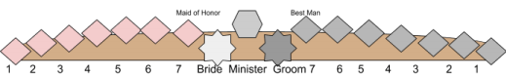Damas Chambelans
1_____________________________________ 1__________________________________ 2_____________________________________ 2__________________________________ 3_____________________________________ 3__________________________________ 4_____________________________________ 4__________________________________ 5_____________________________________ 5__________________________________ 6_____________________________________ 6__________________________________
Quinceanera and Escort:

